Workflow
MRI image
(Directory)
EPRI mouse image
(*.d01/*.exp)
readAcqpGUI
PulseReconGUI
LoadBrukerMRI
PulseFitGUI
EPRI fiducials
(*.d01/*.exp)

PulseReconGUI
Tumor Touch
(*.m)
3DEPRI
AMP_pEPRI

3DEPRI

3DSURFACE

MRI
or
Arbuz GUI
Import options
Diagram 1. Blue: source data; red: MATLAB GUIs; green: ArbuzGUI and plugins.
Load Data
Segment MRI image
Define outline for EPRI
Define outline for fiducials
Build registration framework
SliceMaskEdit
Rotate MRI image to register it
RotateImage
CreateCoordinates
Transfer Tumor mask from MRI image to EPRI image
MaskTransform
Save EPRI tumor mask
(as image mask file)
Tumor Mask file
(*.mat)
Diagram 2. Blue: output data; green ArbuzGUI plugins
ArbuzGUI | ArbuzGUI
Type ArbuzGUI in MATLAB to start ArbuzGUI. ArbuzGUI come with plugins. To run plugins:
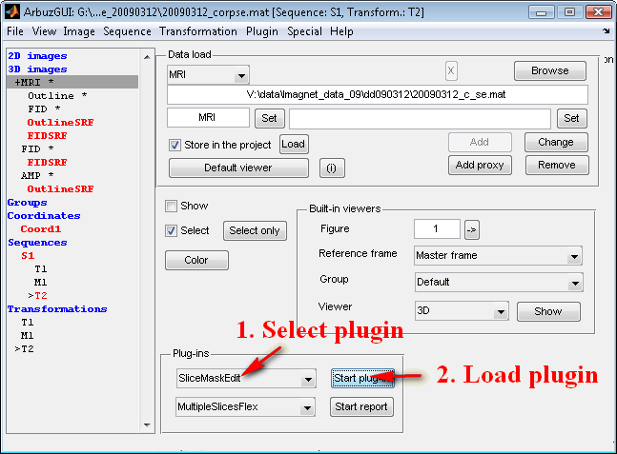
Disclaimer: this picture shows the full project and not the GUI at startup.
MaskTransform
RotateImage
CreateCoordinates
SliceMaskEdit
ArbuzGUI plugins used for registration.

Preparing MRI image | 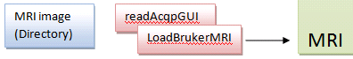
To convert MRI image from BrukerTM standard to mat-file use readAcqpGUI.
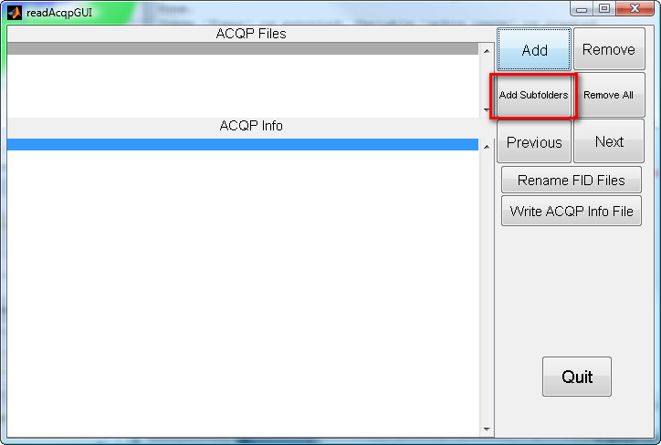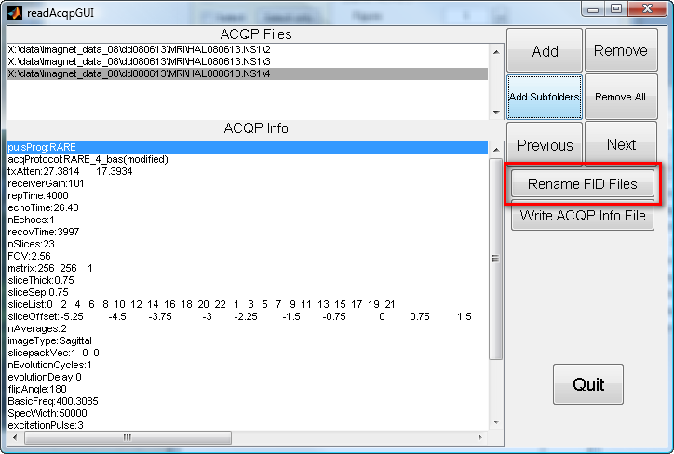
Select directory above the main folder of experimental session. Add MRI file using ‘Add Subfolder’ button. Sometimes if image folder is empty the error will occur and one has to remove the folder. On Vista the straightforward loading does not work and in the open folder dialog one should select the directory of the experimental session. Rename FID files using ‘Rename FID files’ button. Quit.
Run LoadBrukerMRI.
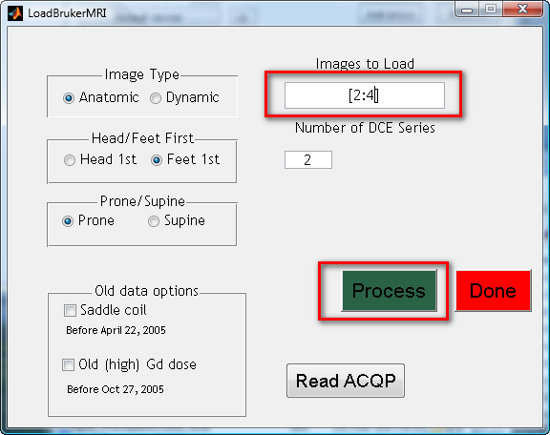
Set correct images to load, Click ‘Process’ button. ‘Done’.

Loading MRI image into ArbuzGUI
Select 3D images. Data type MRI. Be sure that ‘Store in the project’ checkbox is checked. Press Add button. Axial MRI image slices are typically used.
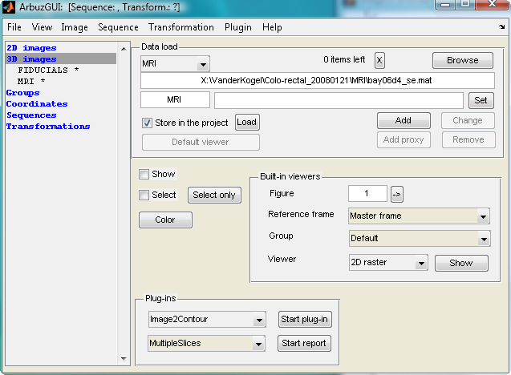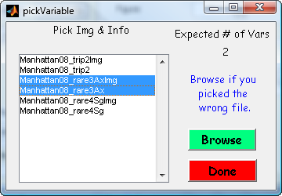

Loading 3D fiducials image (FID) and amplitude (AMP) | 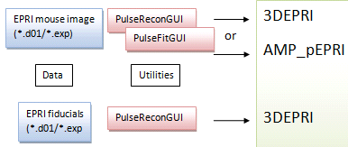

Select 3D images. Data type 3DEPRI for fiducials and not fitted EPRI image. Use AMP_pEPRI for fitted amplitude image. Press Add button after filename and image ID are entered. Make sure that ‘Store in the project’ is checked.
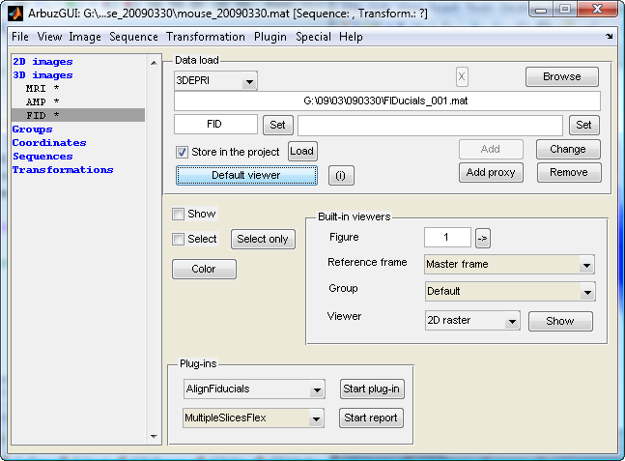

Loading Tumor Touch data
Tumor touch data can provide additional information about the location of tumor boundaries in the EPRI image. Use 3D surface to load standard *.m script with ‘ellipse’ data.

Segmenting images using SliceMaskEdit plugin | 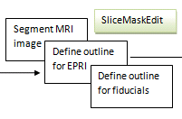
Load SliceMaskEdit plugin.

MRI image:
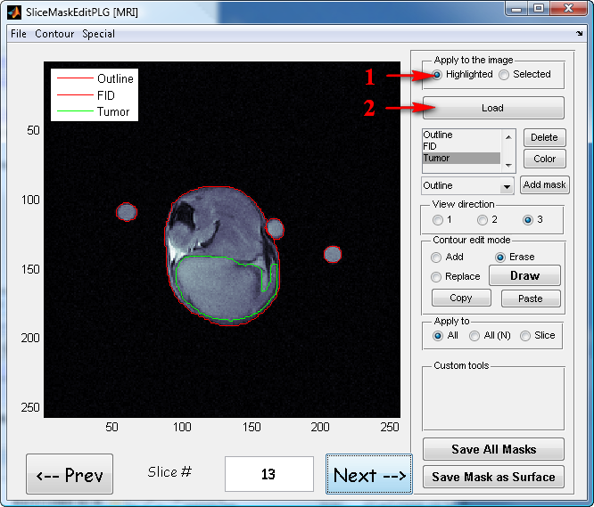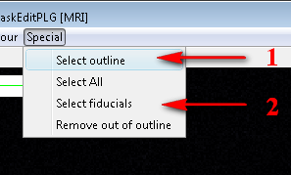
Load MRI image (see the Figure for steps 1 and 2). Use Special/Select outline to select outline. The threshold of 0.15 is typically appropriate. Use mask edit tools from the Contour menu (see also shortcuts) to correct the outline. Exclude all fiducials from outline.
Use Special/Select fiducials to select fiducials. Threshold and exclude mask should be 0.15 and ‘Outline’.
Use Ctrl-M to select convenient colormap. Use Ctrl-I to adjust the intensity. Click inside figure to store the settings.
Create ‘Tumor’ mask. Select ‘Tumor’ mask. If image quality allows use interactive threshold from Special dialog to map tumor using its intensity. Otherwise use tools from Contour menu.
Press Save all Masks to store mask information.
Save Outline and FID masks as surfaces. Important: masks can be converted to surfaces but not the opposite. Remember to save masks.

Do not forget to save the project on different stages of processing!
File / Save project.

Process Fiducials image
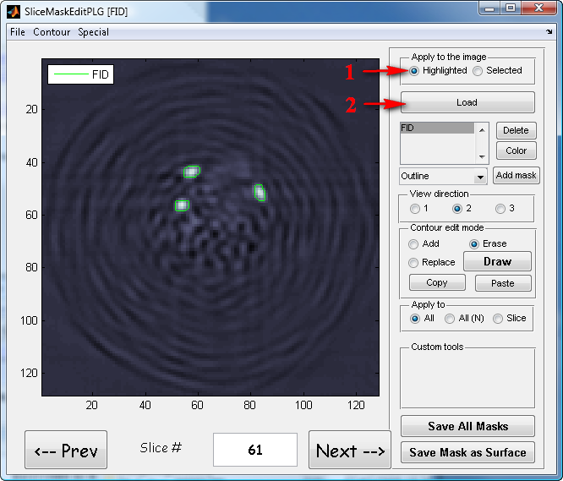
Create ‘FID’ mask. Use Special/Select All with low threshold of ~0.25 to select the mask. Remove all excessive selection. If image quality allows use interactive threshold. Press Save all Masks to store mask information.
Select FID mask and save it as a surface.

Process AMP image.
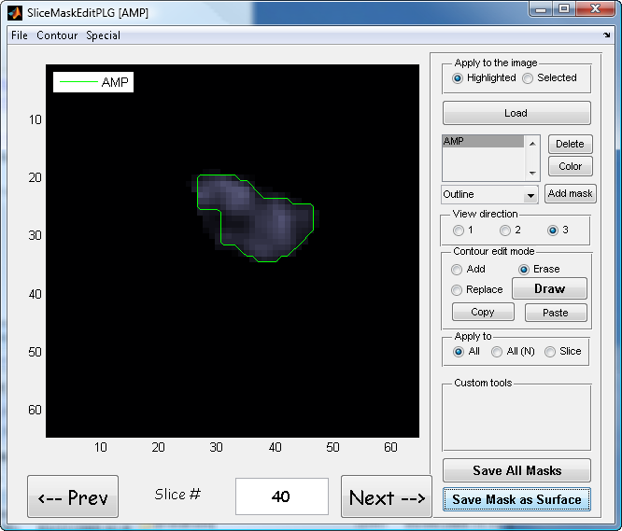
Create ‘AMP’ mask. Use Special/Select All with low threshold of ~0.25 to select the mask. Remove all excessive selection. If image quality allows use interactive threshold. Press Save all Masks to store mask information into project.
Select AMP mask and save it as a surface.

Use wizard to create sequence S1 and three transformations T1, T2, M1. | 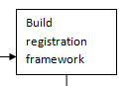
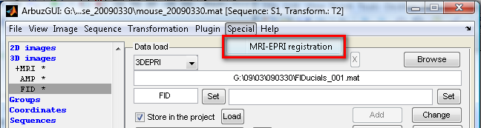
The result will be:
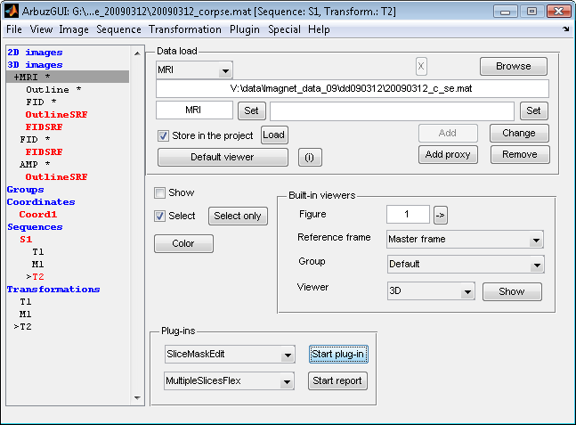

Do not forget to save the project on different stages of processing!
File / Save project.

Image registration | 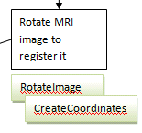
Color all surfaces in different colors using Color button in ArbuzGUI. Use either edge color or face color with face alpha below 0.4.
Leave for show only MRI and EPRI fiducials surfaces. Select 3D viewer and press Show in button.

Create convenient system of coordinates.
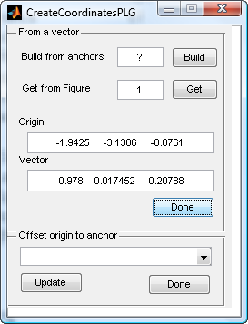 | Orient figure exactly perpendicular to one of EPRI fiducials. Open CreateCoordinates plugin  Press Get (Get from figure) button, move the cursor to the fiducial center and click there.  Press Done button in the ‘From a vector’ panel. The default name of coordinate system is OK.
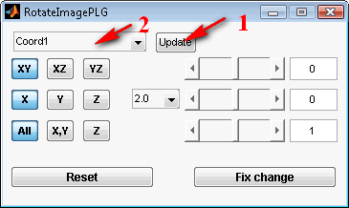 | Open RotateImage plugin. Press the Update button to see new coordinate system, and then select it.
Make one of the MRI fiducials and EPRI fiducials aligned. Use rotations (XY, XZ, YZ) and translations (X,Y,Z). Scaling (All, X,Y, Z) should not be used.

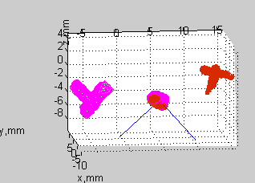
After each rotation (XY, XZ, YZ) – press fix. Translations (X,Y,Z) do not need to be fixed frequently.
After one fiducial is aligned, use only XY rotation and Z translation to align other fiducials.
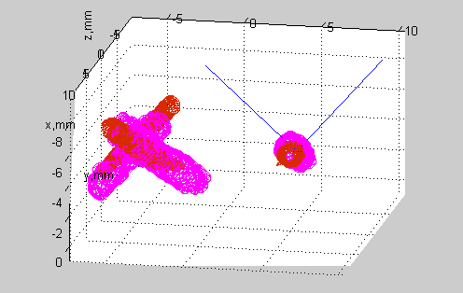
Use Tumor Touch surface and outline of MRI and EPRI image to further optimize the registration.
Press Fix change button.
Done!

Transfer mask from MRI image to EPRI image | 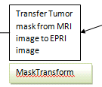
Use MaskTransform plugin.
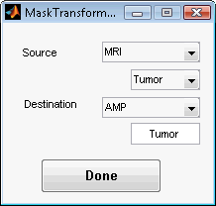
Save the mask | 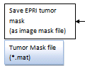
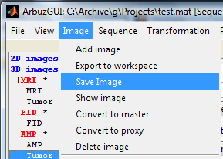
Use Image mask save format.

Do not forget to save the project !
File / Save project.
Complete project with all used windows and plugins open

